* Initialize a Git Repository

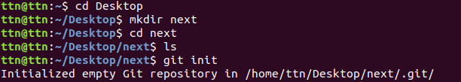

At first we will make a folder “next” then with the help of cd command we will go to “next” folder and then we will use git init to intialize a repository.

* Add files to the repository

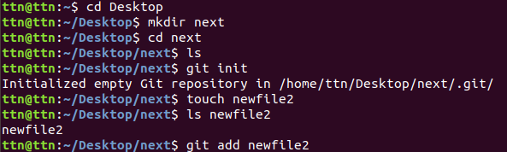

After the process of initializing the repository we willl make a file “newfile2” and then we will add newfile2 to the repo by using git add newfile.

* Commit the file

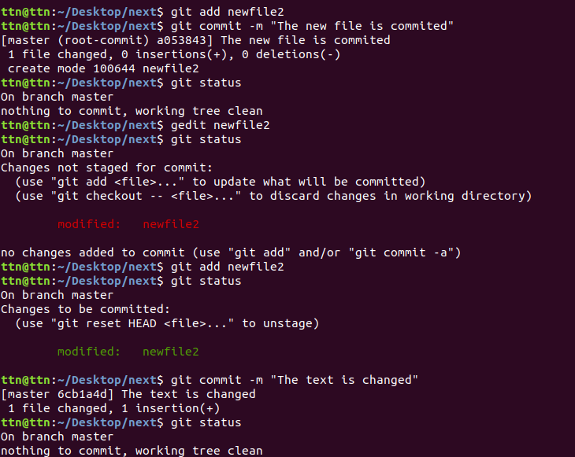
After adding newfile2 we will use git commit and then use gedit so that we can enter the text and then after saving it we will add the file and on checking the status we see the changes are to be commited and then we will again commit the file and at last the file gets commited showing text nothing to commit.

* Add a remote

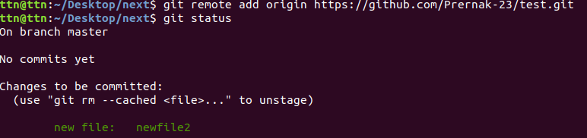

Here we added a remote named origin whose url is the one when we made a repository named test .

* Undo changes to a particular file

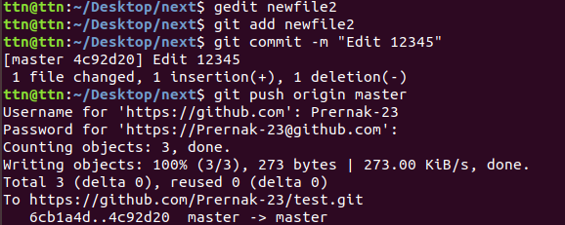

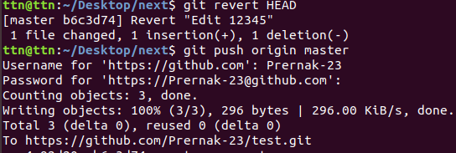
In this condition first we make changes in the same file i.e newfile2 and then we will commit it
and then after pushing we will use revert HEAD and after that we will get the same text that we had in the file.

* Push changes To Github

The use of git push command is to upload local repository content to a remote repository.Now after we have undo the changes we will use git push command so that we can push the changes to Github.

* Clone the repository

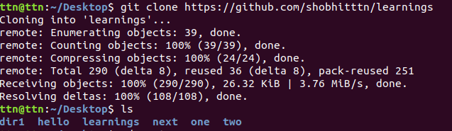

At first we need get out of the next folder using cd .. and then we will start with the cloning of
the repository git clone is primarly used to point to an existing repo and make a clone or copy of that repo at in a new directory at another location. After using clone we can easily use ls to list the desktop for checking the presence of the folder.

* Check differences between a file and its staged version

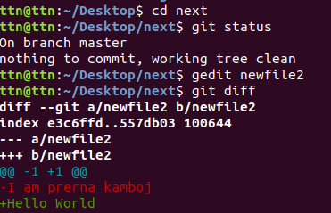

For the differences between a file, first we went to the next folder . Earlier we had a text in newfile2 and then using gedit we changes the text with Hello world . Now with the help of
git diff we were able to check the differences between the file newfile2.

* Ignore a few files to be checked in.

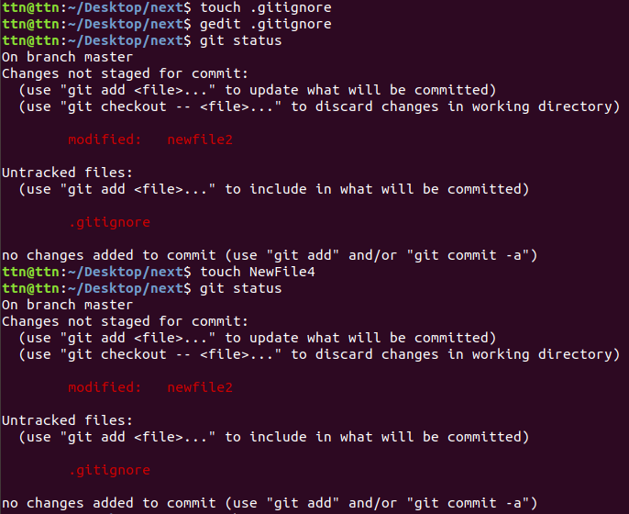
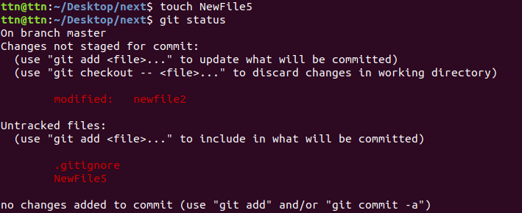

The use of gitignore is that it doesnot show the files we want to ignore .In the second screenshot it is shown that the NewFile5 created was not set for gitignore so when git status was used NewFile5 was displayed.

* Create a new branch

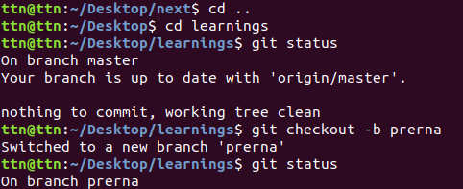

* Try merging them and resolve merge coflicts.

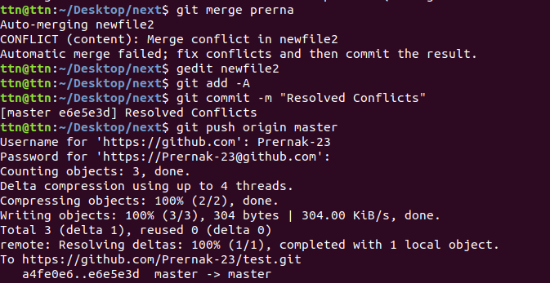

Here with the help of git merge command we merged the branches and then in the case of resolving conflicts after using gedit we added the content using -A and then we commited the file with the message and after the confict got resolved we pushed the file.

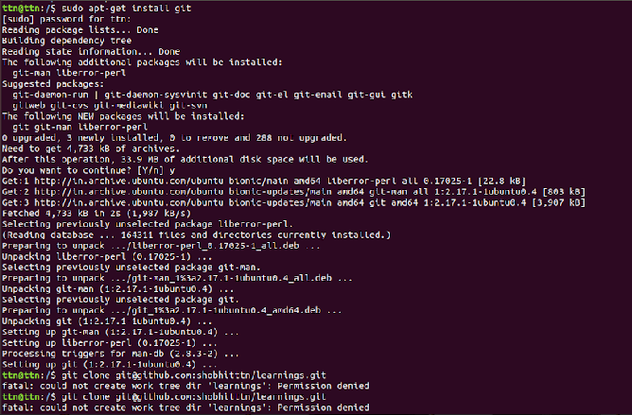

* Git Setup https://confluence.atlassian.com/bitbucket/set-up-git-744723531.html

* Stash the changes and pop them.

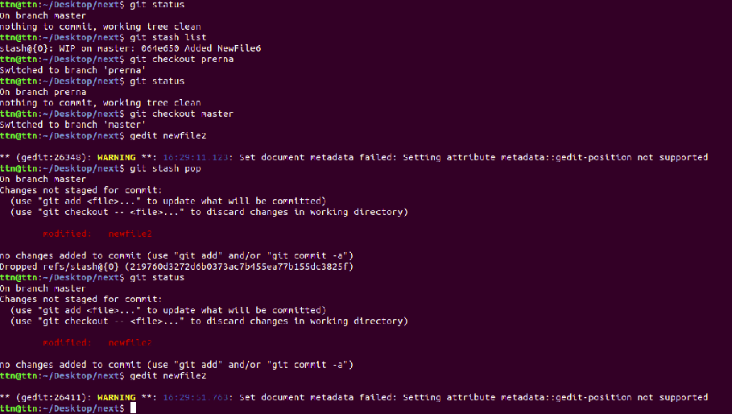
We used git stash pop command and reverted the unsaved changes.

* Add changes to one of the copies and pull the changes in the other.

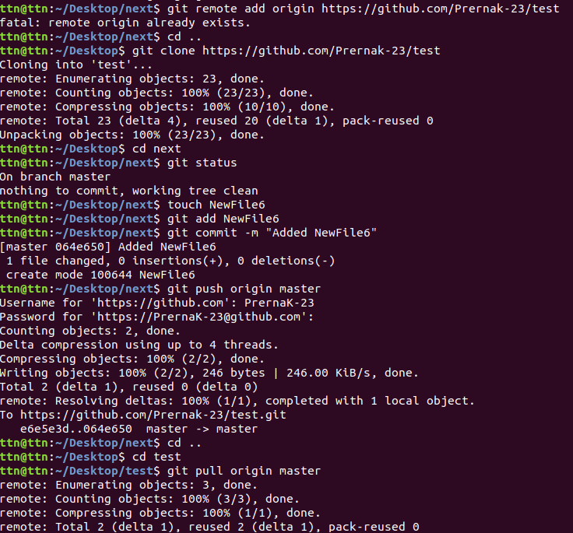
First we made new folder which was made with use of clone so the name is test .Then in one of the two folders that is next we will make a new file that is NewFile6 and then we will add and commit and then we will push. After that coming to the other folder test we will pull it.

* Add the following code to your .bashrc file : color_prompt="yes"
parse_git_branch() {
git branch 2> /dev/null | sed -e '/^[^*]/d' -e 's/* \(.*\)/(\1)/'
}
if [ "$color_prompt" = yes ]; then
PS1='\u@\h\[\033[00m\]:\[\033[01;34m\]\W\[\033[01;31m\] $(parse_git_branch)\[\033[00m\]\$ '
else
PS1='\u@\h:\W $(parse_git_branch)\$ '
fi
unset color_prompt force_color_prompt

